### In-Depth Analysis

First of all I have split the data into 80/20 ratio i.e. 80% of the data has been used to train the model and remaining 20% used for the testing purpose.

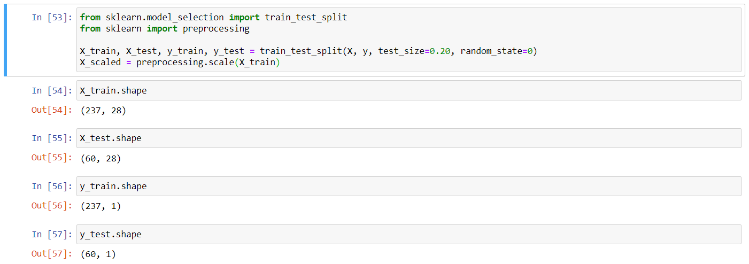

I have applied various algorithms like Linear Regression, Naive Bayes, SVM, KNN, Decision Tree, XGBoost, Neural Neural and Random Forest on the data-set and tested them for their accuracy. Finally I have compared their accuracy. The accuracy can be further increased by performing hyper parameter tuning.

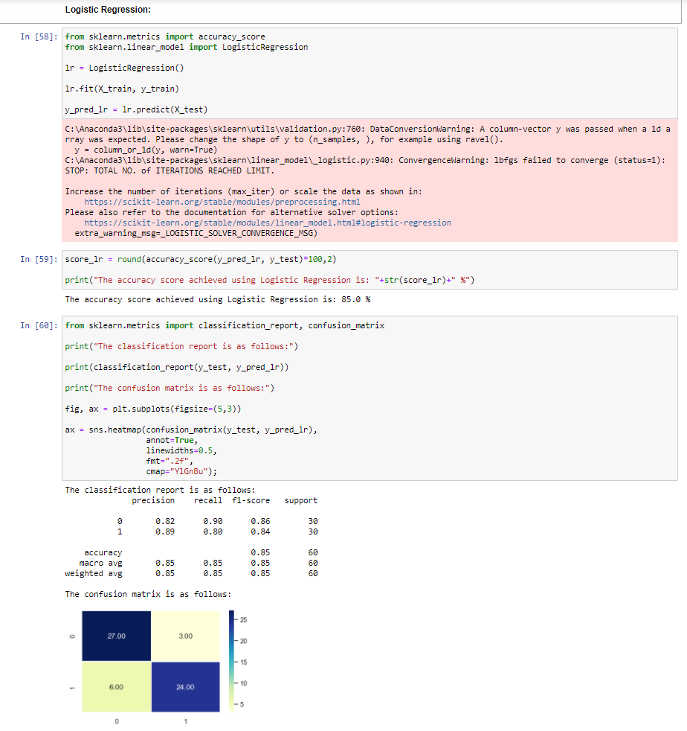

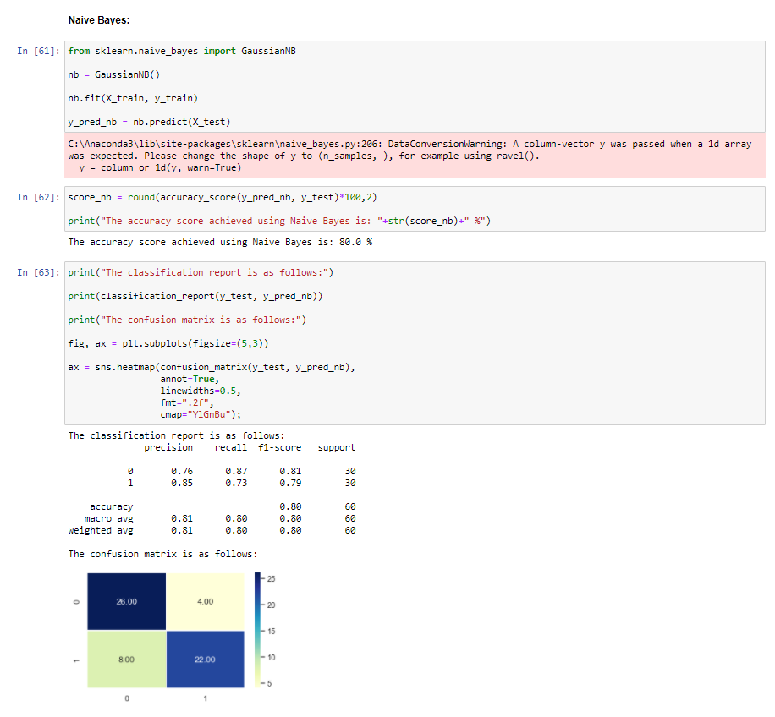

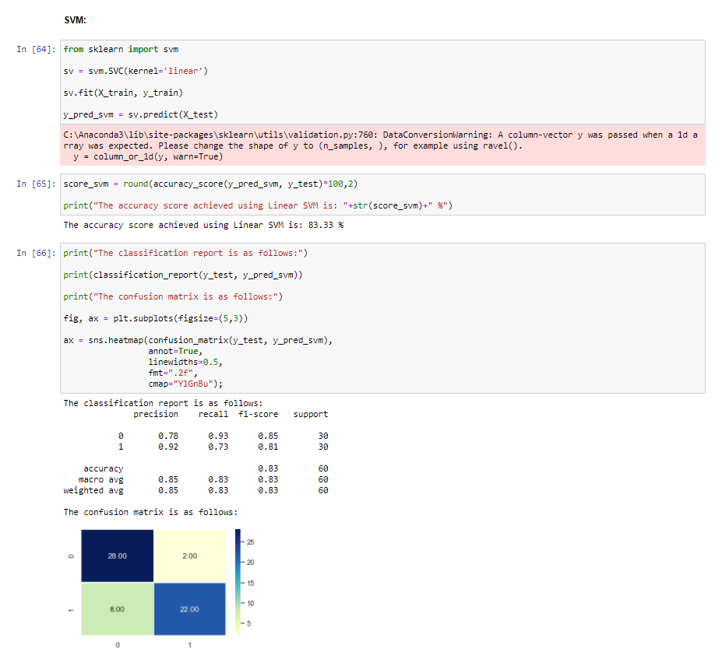

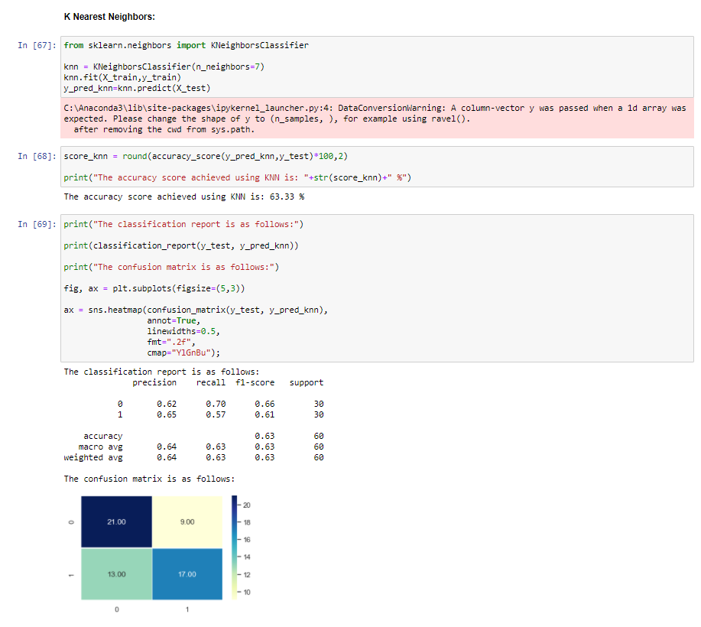

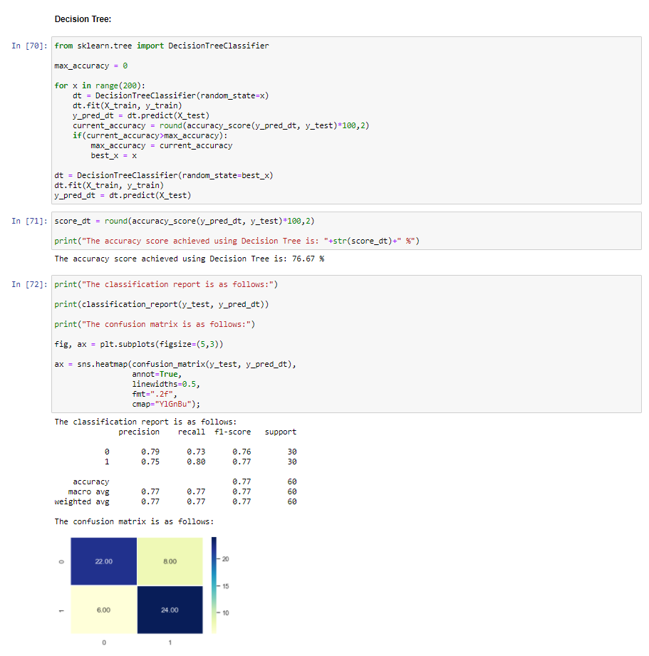

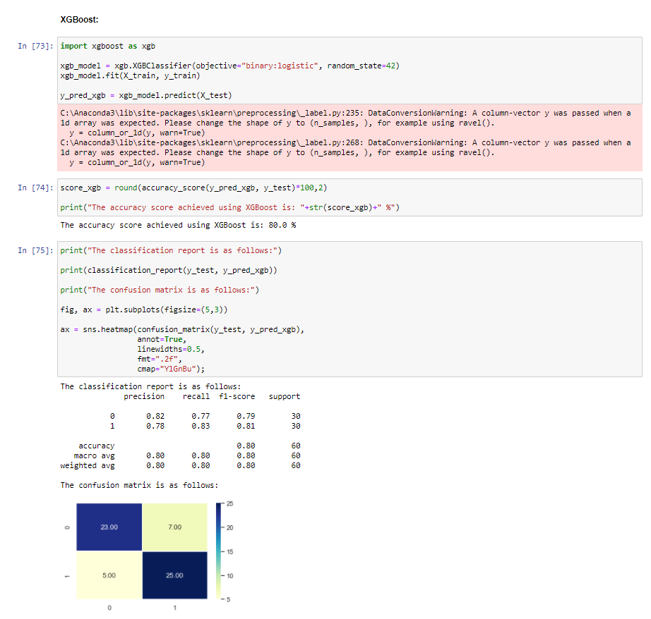

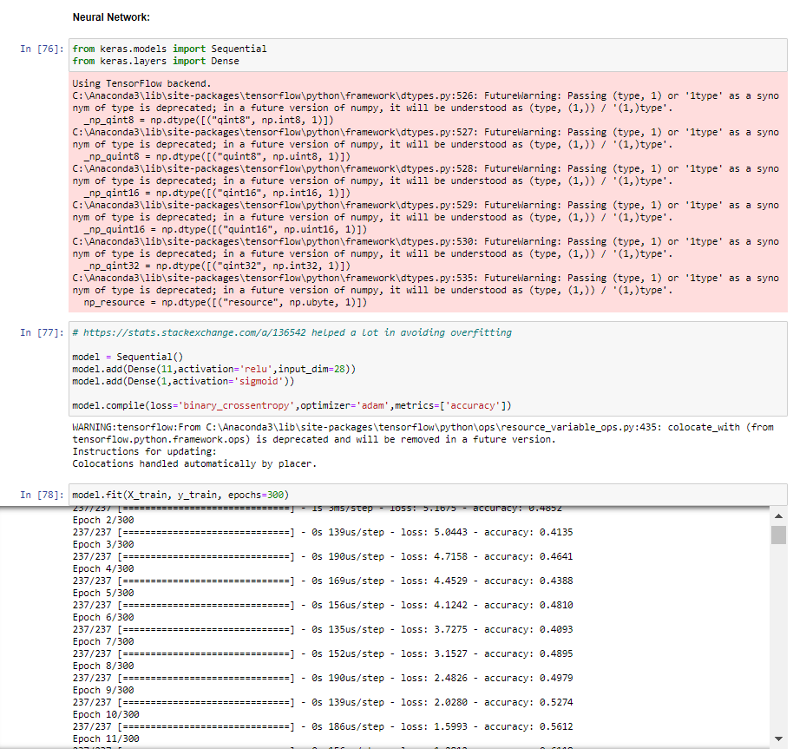

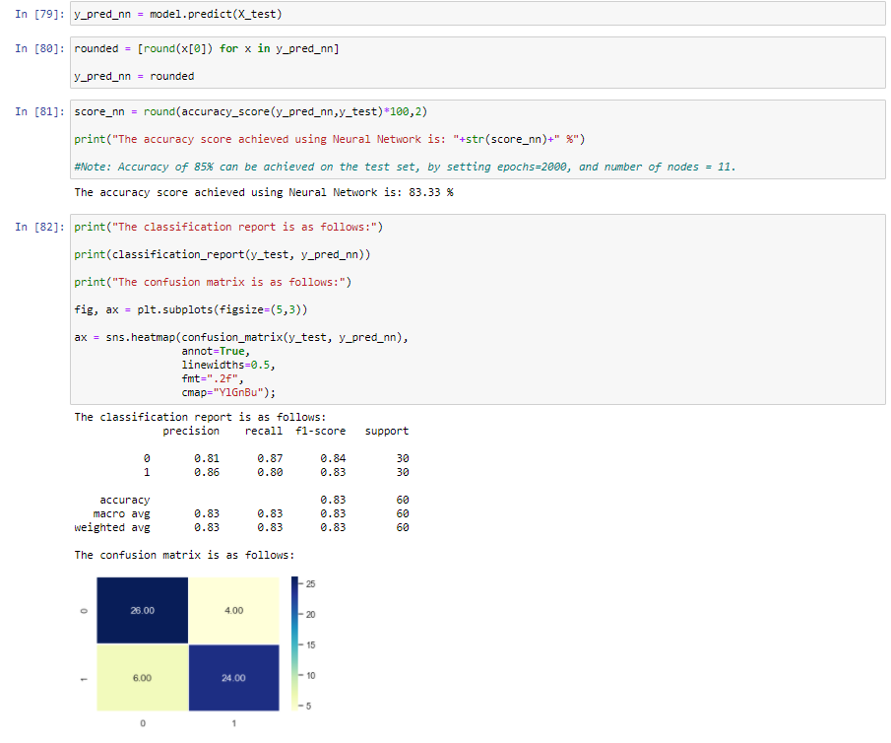

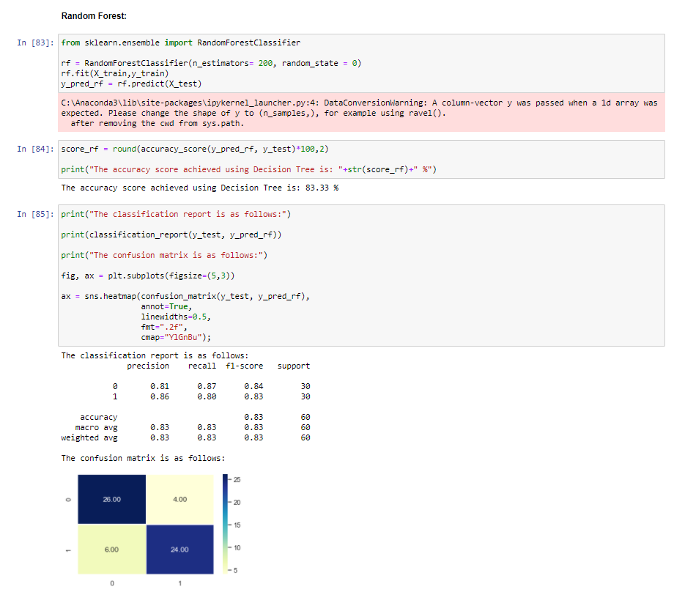

Finally the accuracy of all the models have been compared against one another.

